**Lab_task_04**



**Spring 2024**

Submitted by:

**Waqas Khan**

Class Section: **A**

“On my honor, as student of University of Engineering and Technology, I have neither given nor received unauthorized assistance on this academic work.”

Submmited to: Syed Adeel Ali Shah Associate Professor CS&IT UET Peshawar

Month, Day, Year (11/ 03/ 2024)

Department of Computer Science

University of Engineering and Technology, Peshawar.

**Exercise 1: Constructor Overloading**

* **Task:** Create a class Book with two constructors: one that initializes only the title and another that initializes both the title and the author. Implement a method to display the book details.
* **Output:**

Book Title: The Great Gatsby

Author: Unknown

Book Title: 1984

Author: George Orwell

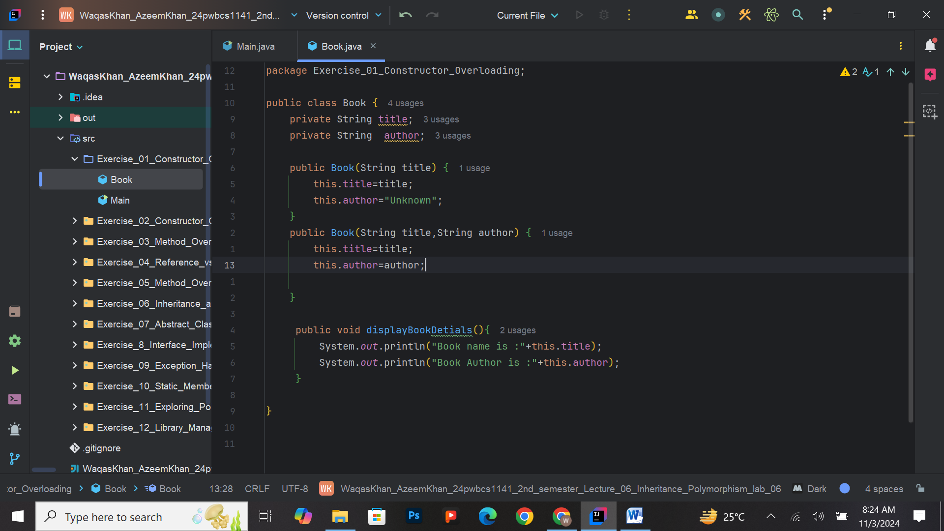

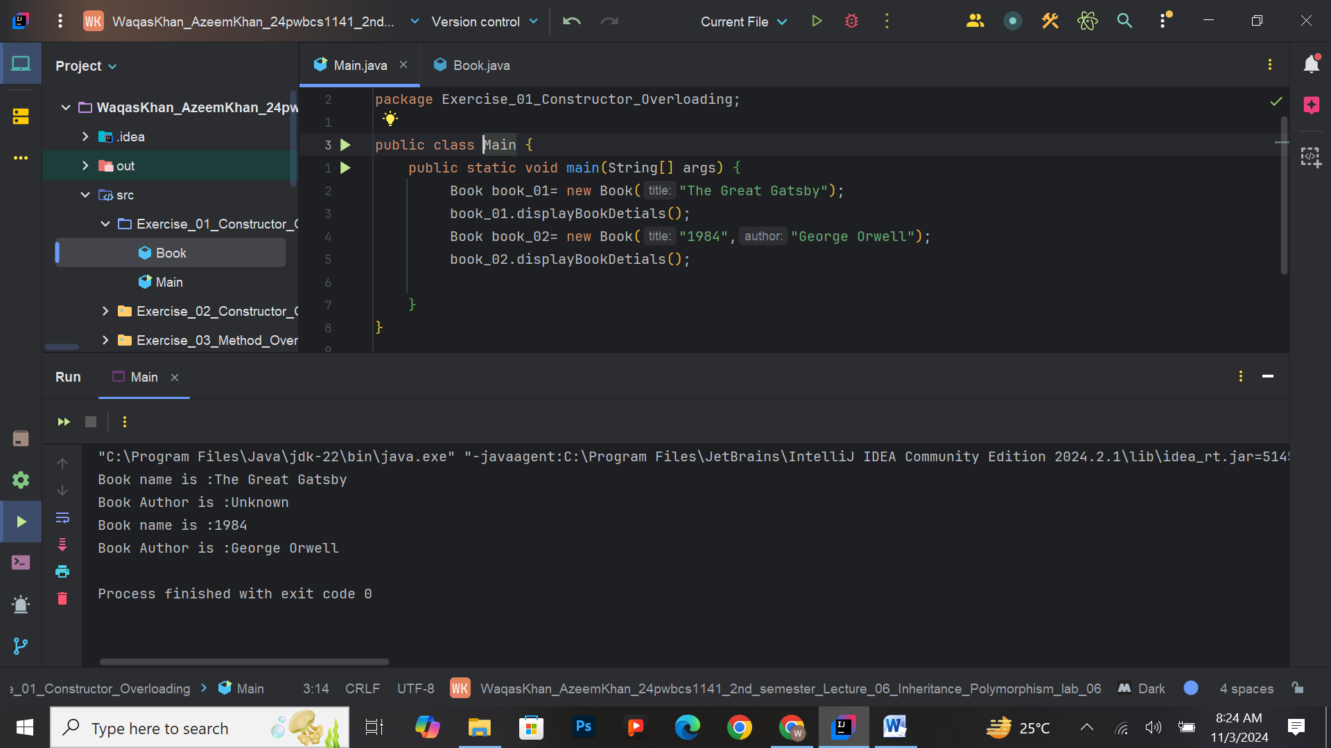

**Exercise 2: Constructor Chaining**

* **Task:** Implement a class Person with a constructor that initializes the name. Use constructor chaining to create another constructor that initializes both name and age. Display the person’s details.
* **Output:**

Name: Alice

Age: 0

Name: Bob

Age: 25

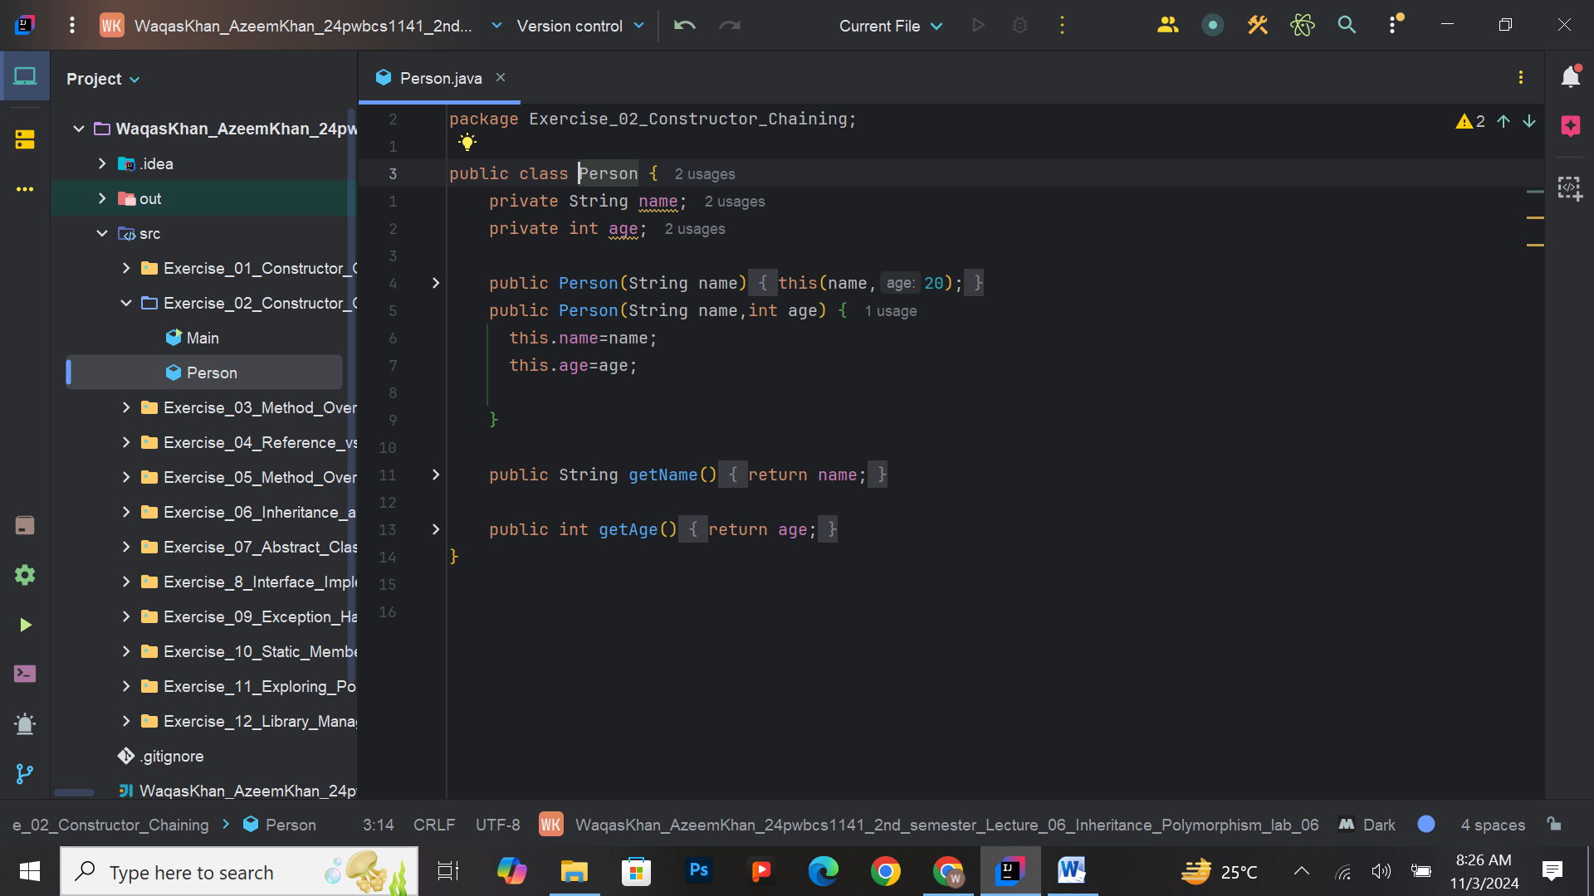

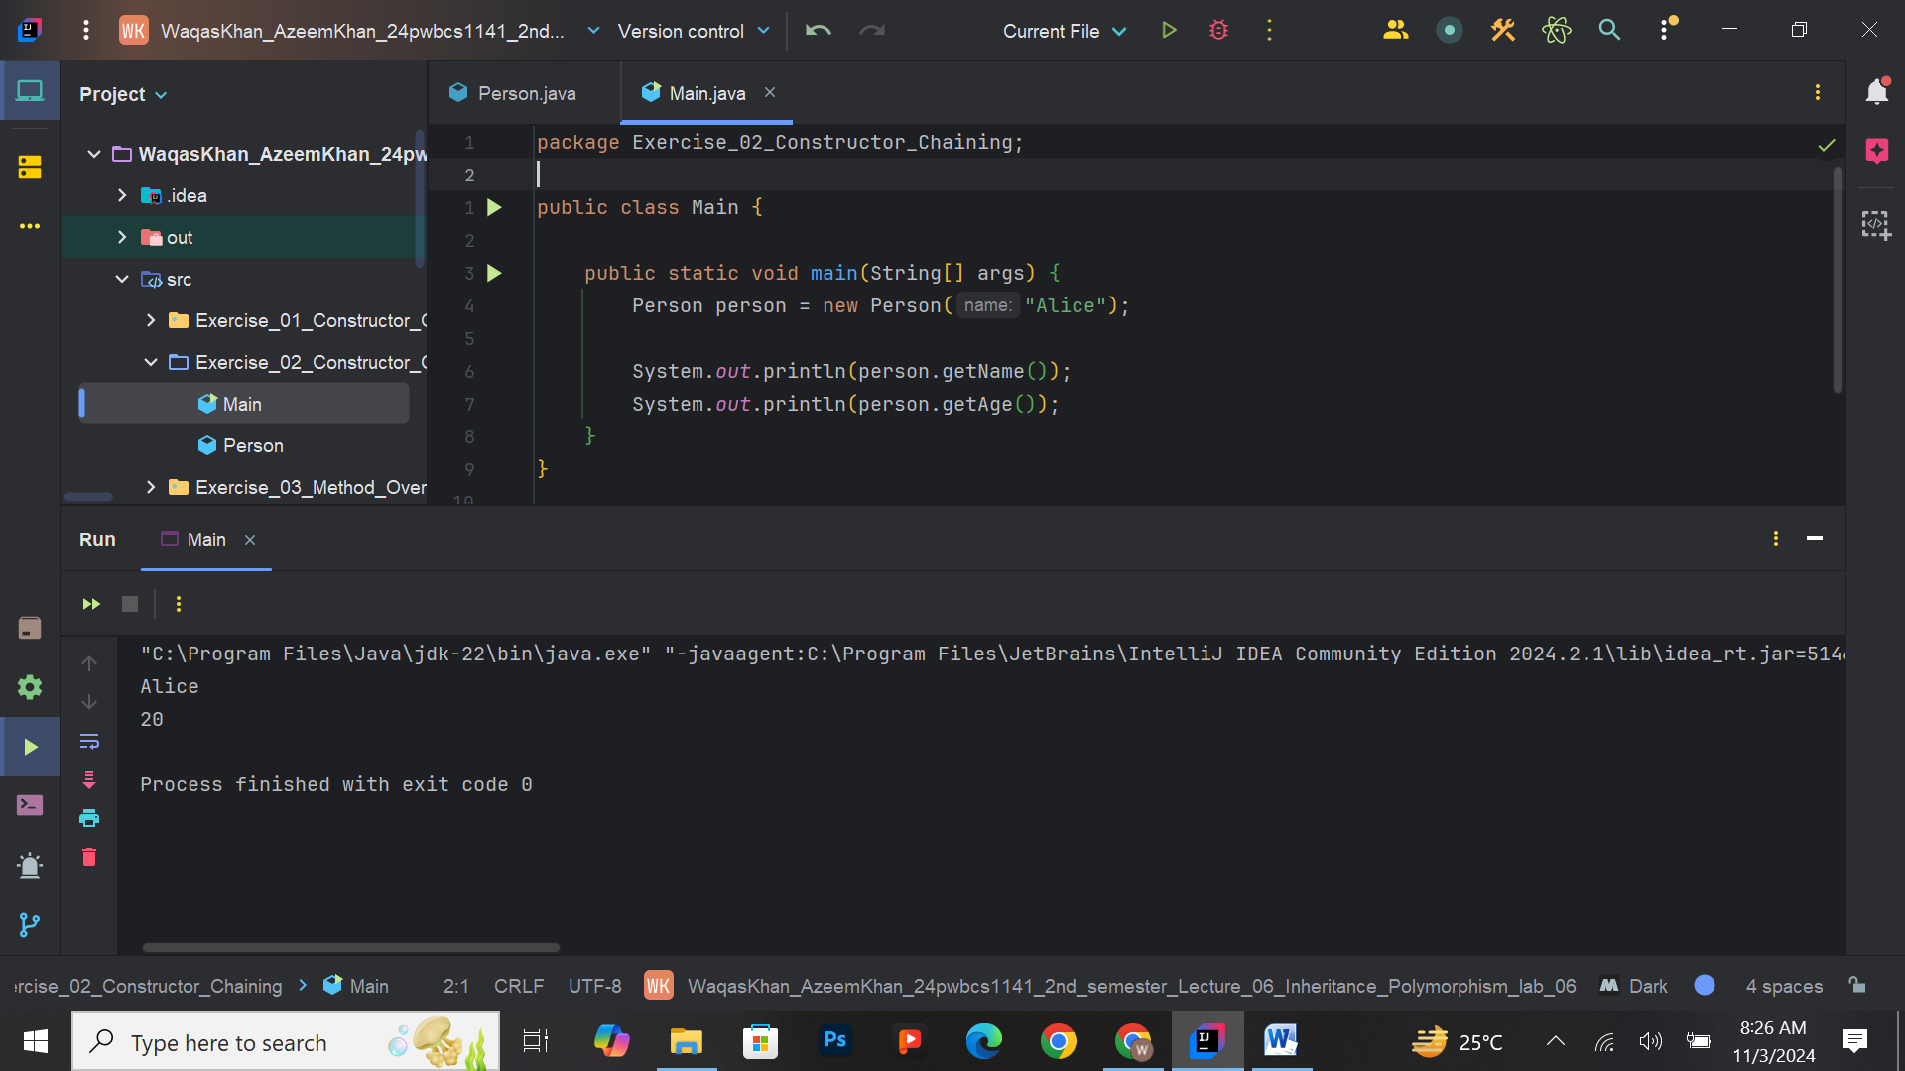

**Exercise 3: Method Overriding**

* **Task:** Create a base class Shape with a method area(). Derive classes Circle and Rectangle from Shape and override the area() method to return the area of the respective shape. Demonstrate polymorphism using an array of Shape references.
* **Output:**

Circle Area: 78.5

Rectangle Area: 30.0

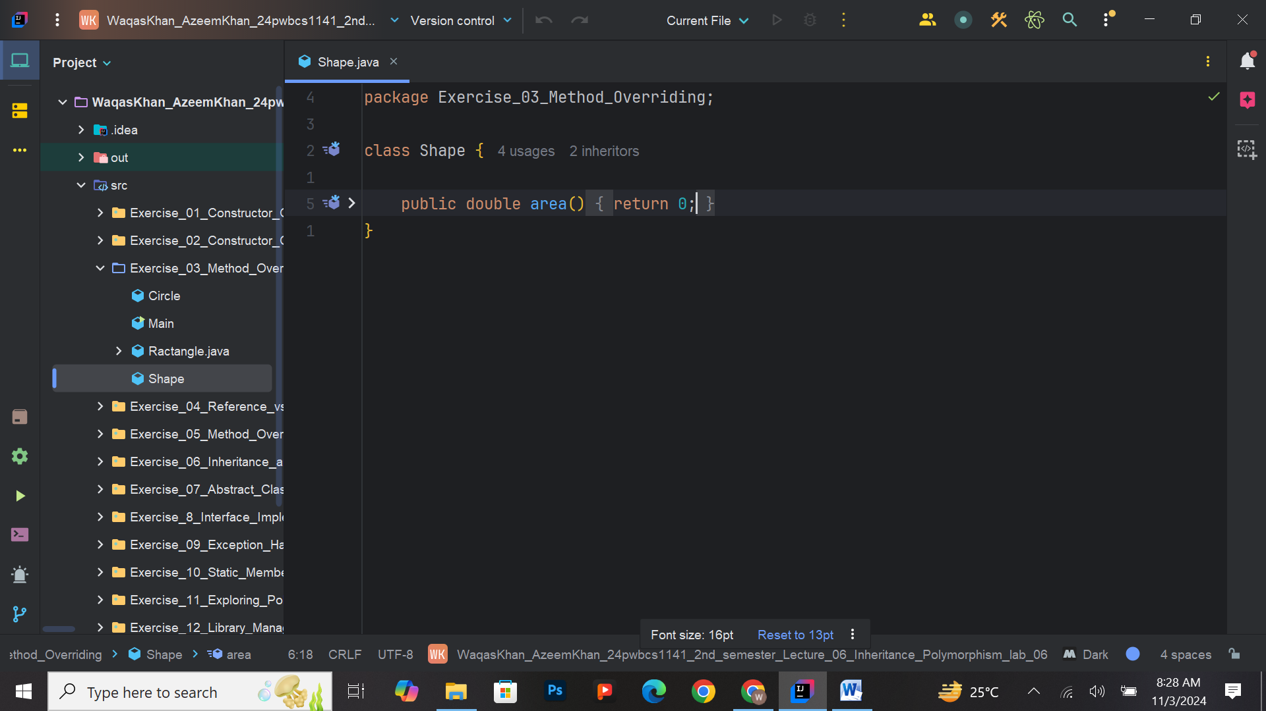

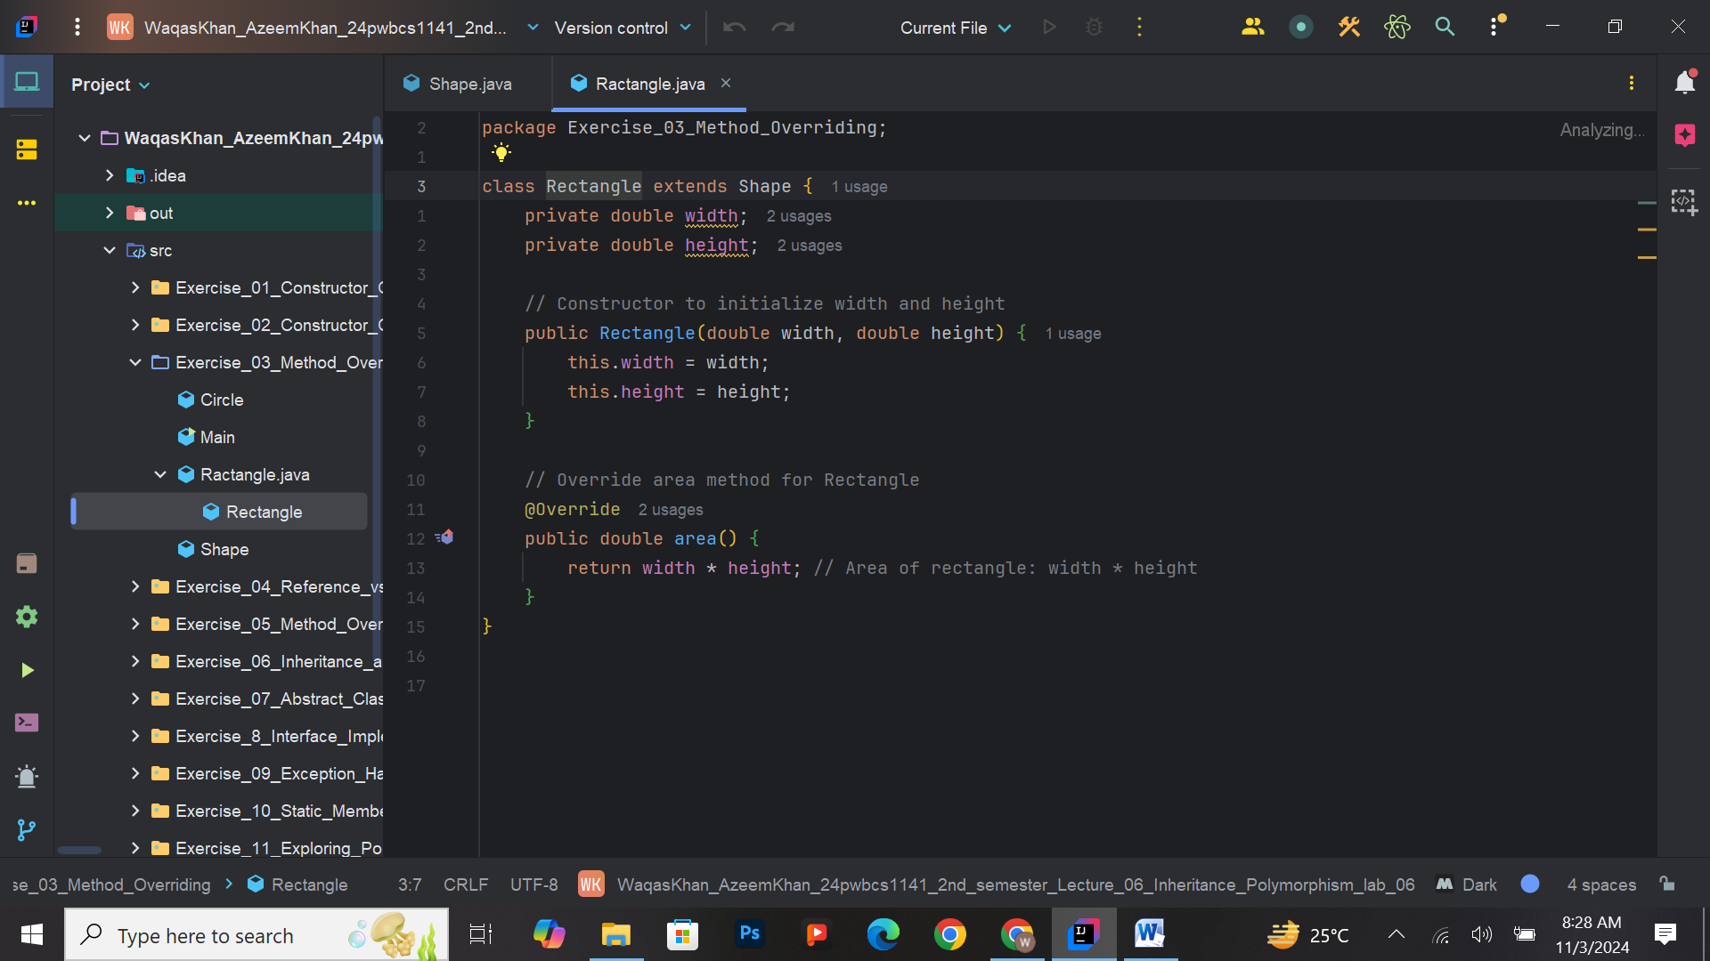

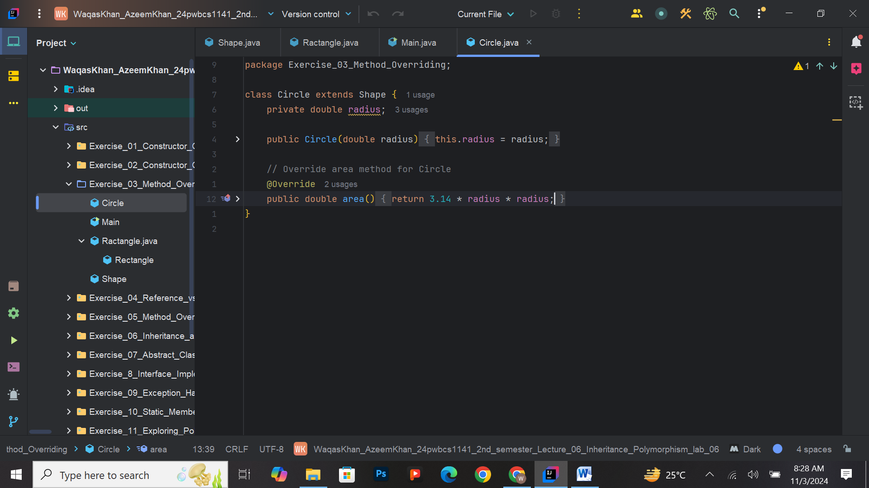

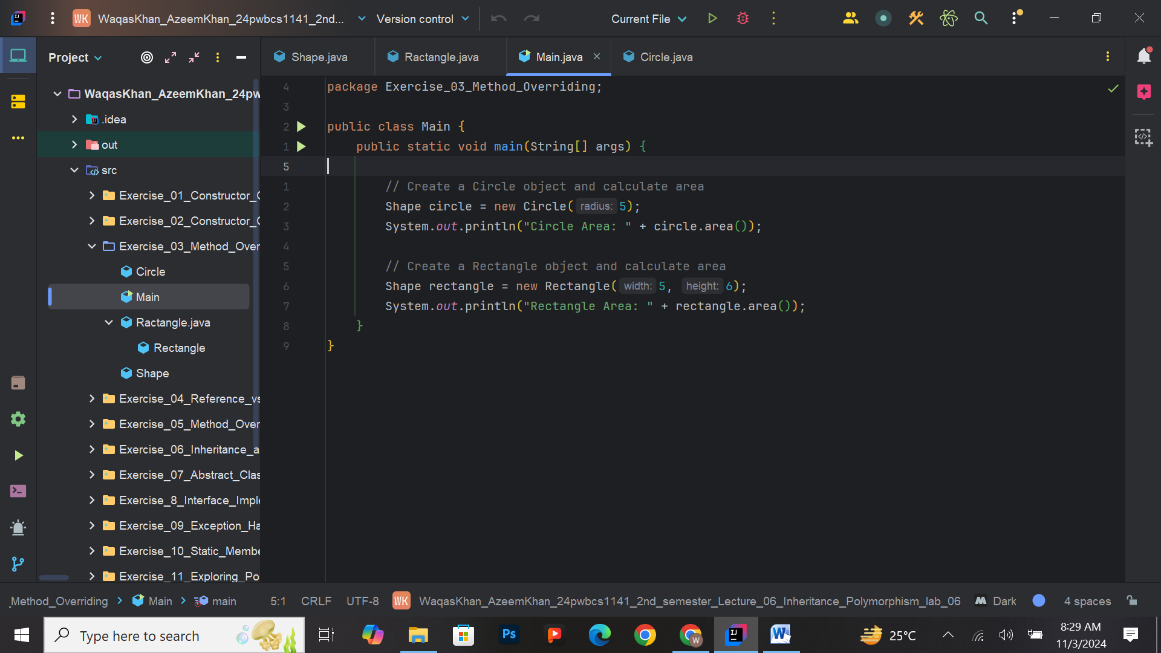

**Exercise 4: Reference vs Object**

* **Task:** Create a class Car with a model property. Instantiate a Car object and use a reference variable to access and display the car's model.
* **Output:**

Car Model: Tesla Model 3

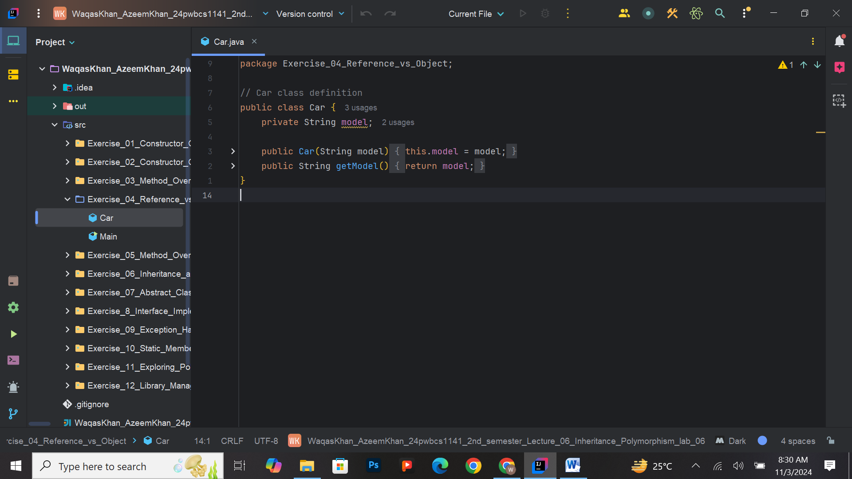

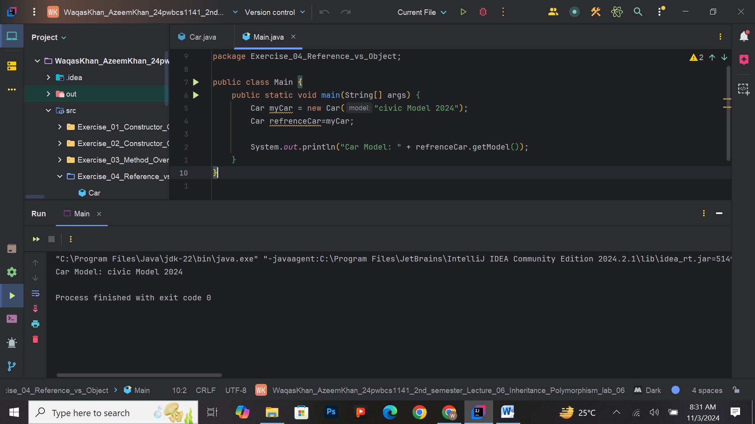

**Exercise 5: Method Overloading**

* **Task:** Implement a class Calculator with overloaded methods for add(). Create methods to add two integers, three integers, and two doubles. Display the results of each method call.
* **Output:**

Sum of 3 and 5: 8

Sum of 3, 4, and 5: 12

Sum of 2.5 and 3.5: 6.0

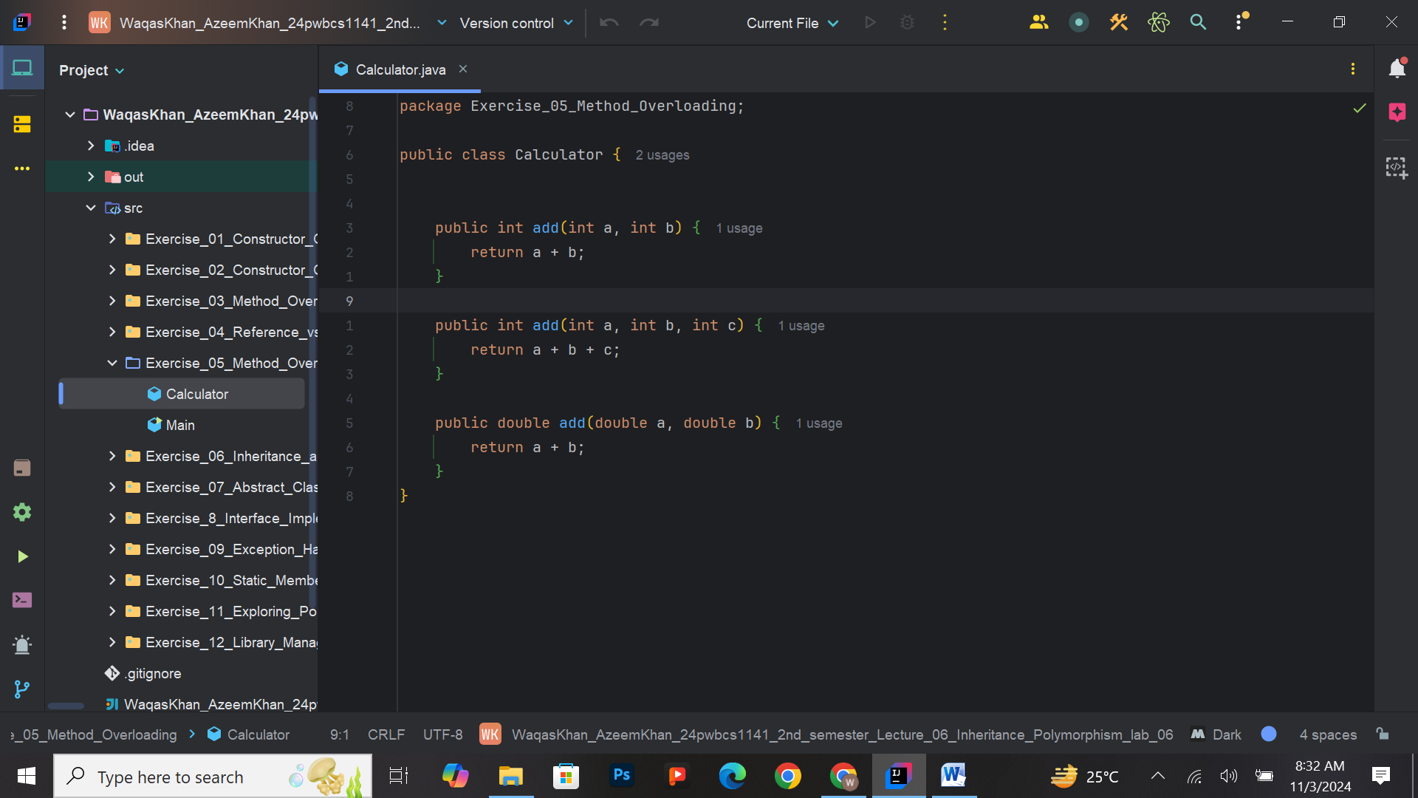

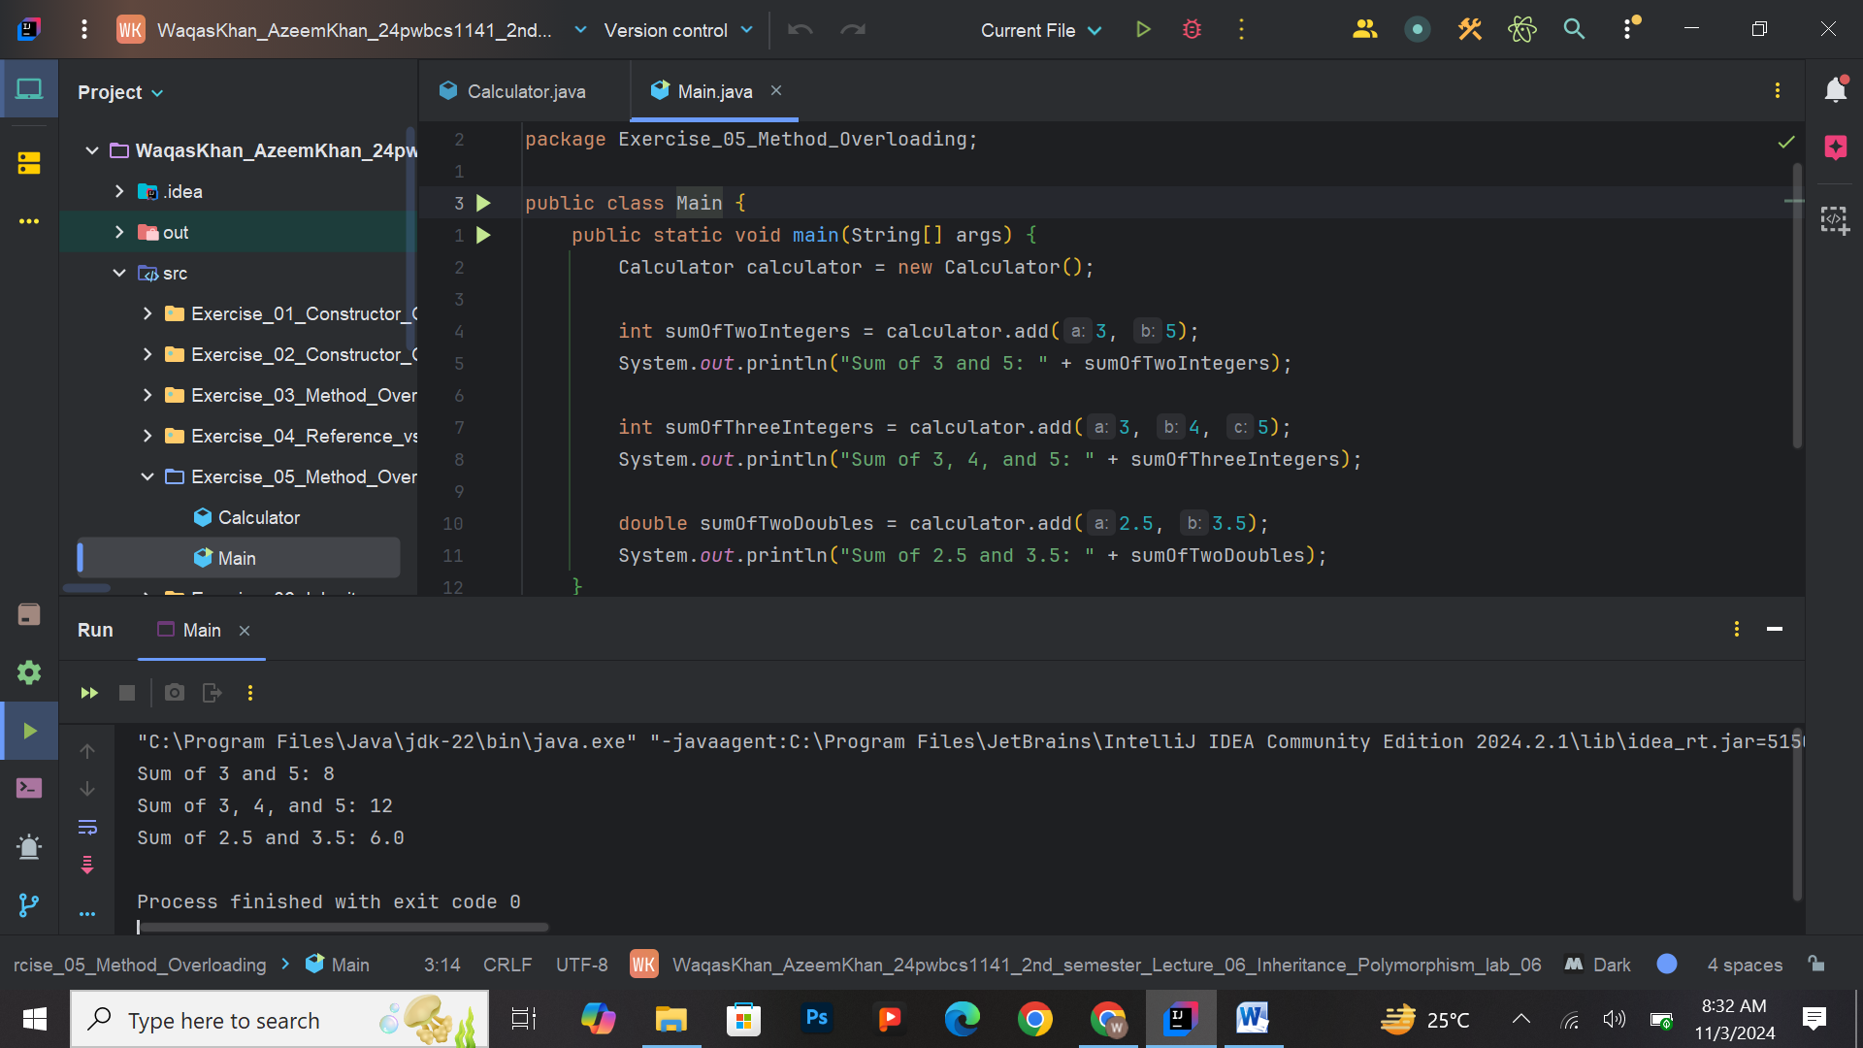

**Exercise 6: Inheritance and Super Keyword**

* **Task:** Create a class Employee with properties like name and salary. Derive a class Manager from Employee and add an additional property department. Use the super keyword to initialize inherited properties. Display the details of a manager.
* **Output:**

Name: John Doe

Salary: 60000

Department: Sales

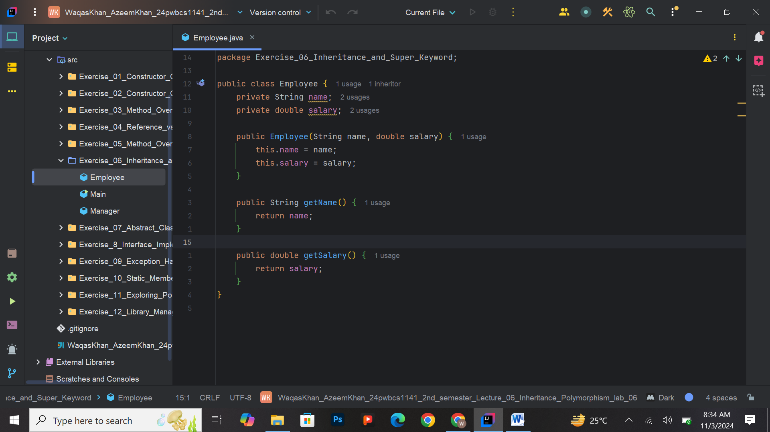

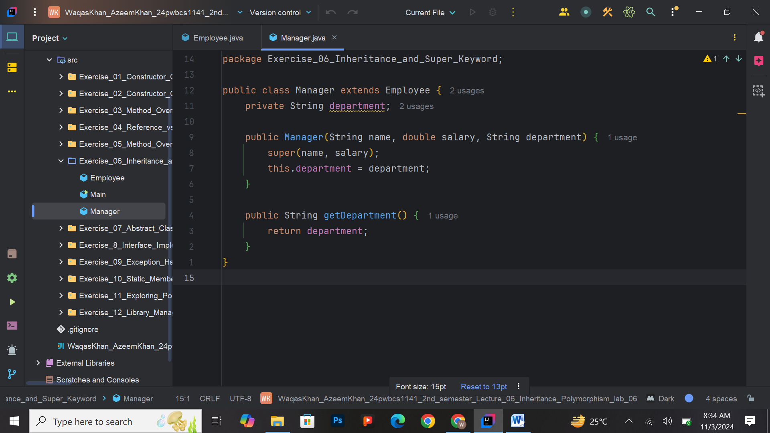

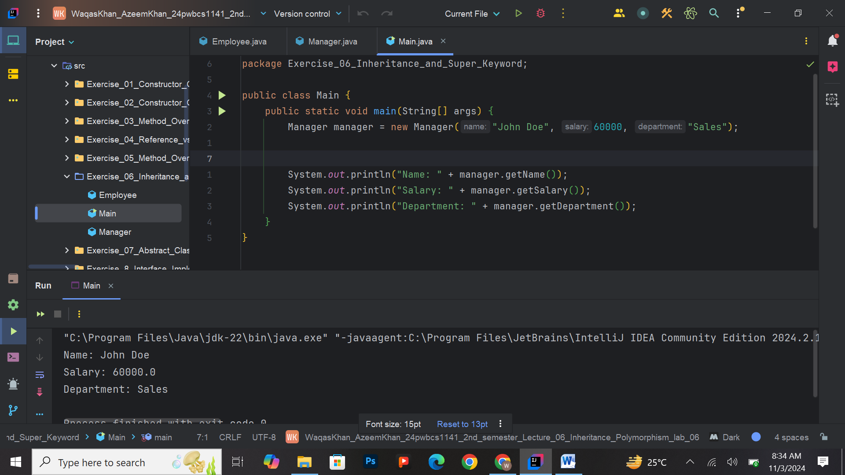

**Exercise 7: Abstract Classes**

* **Task:** Create an abstract class Appliance with an abstract method turnOn(). Derive classes WashingMachine and Refrigerator from Appliance and implement the turnOn() method. Demonstrate the functionality.
* **Output:**

Washing Machine is now ON.

Refrigerator is now ON.

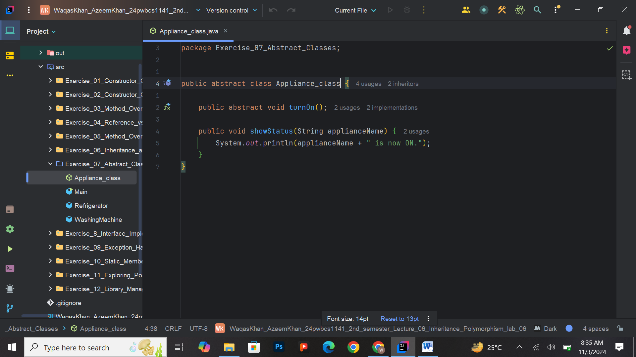

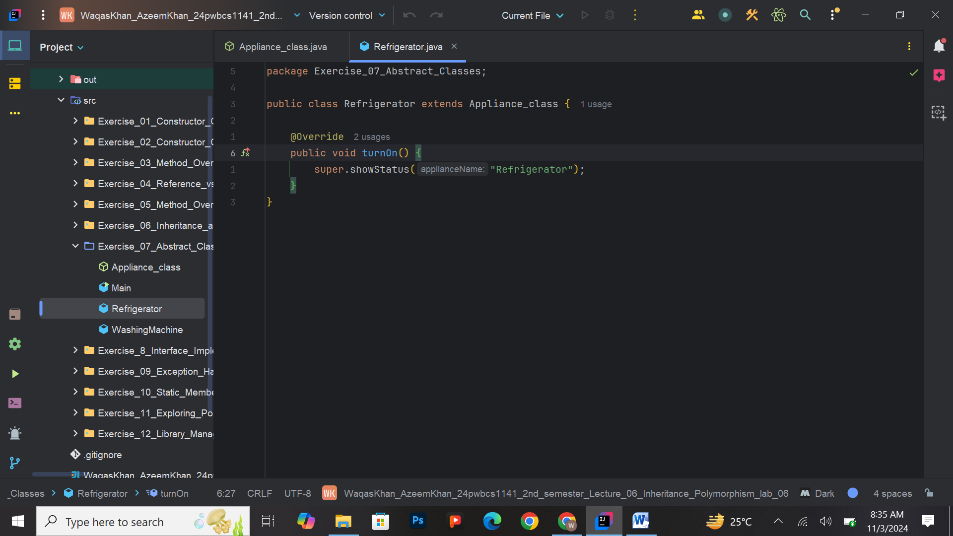

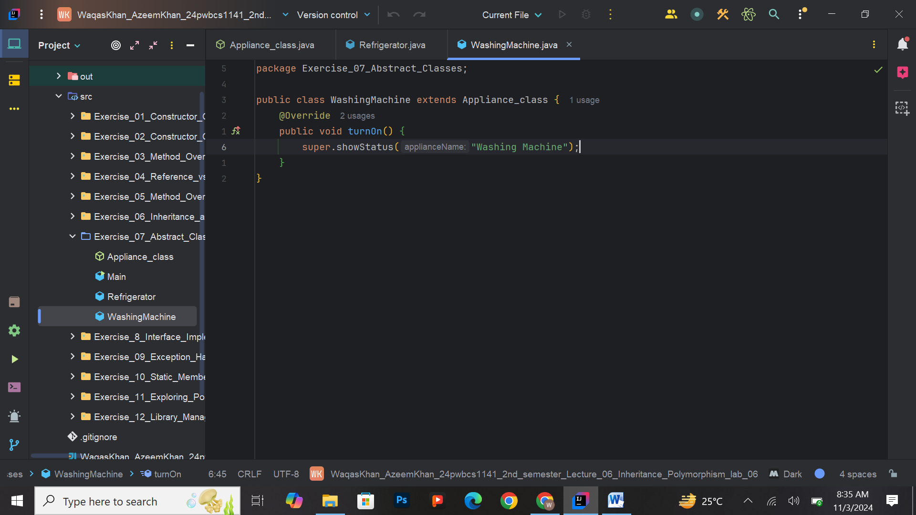

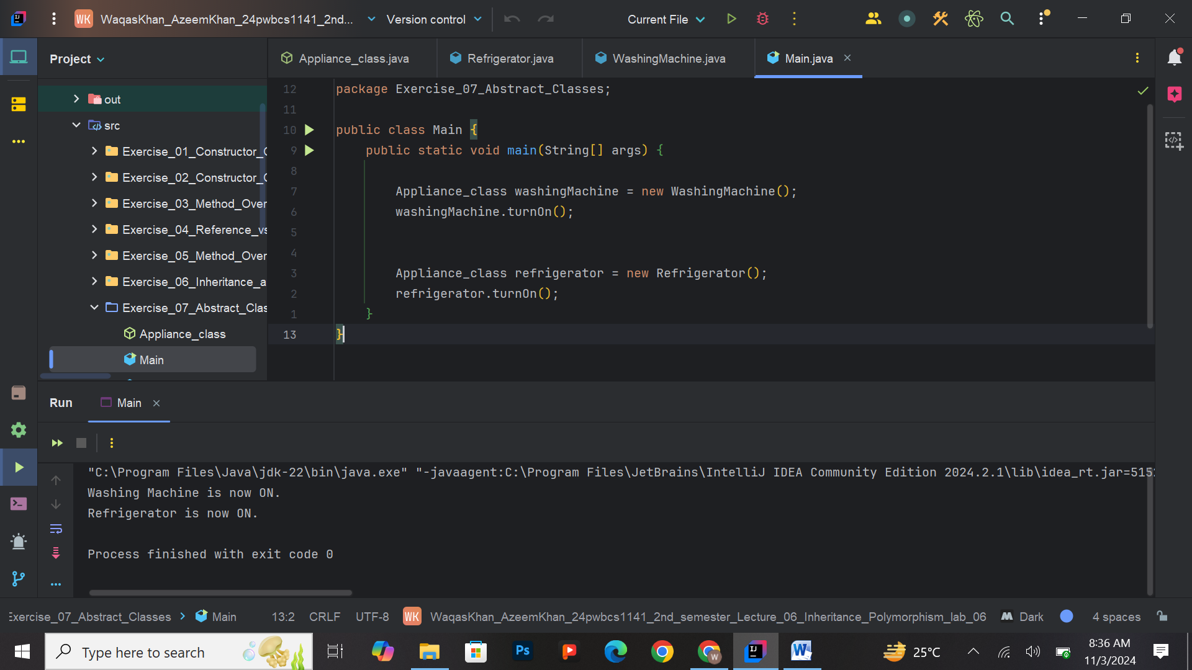

**Exercise 8: Interface Implementation**

* **Task:** Define an interface Playable with a method play(). Create classes Song and Video that implement this interface. Call the play() method for each.
* **Output:**

Playing song: Shape of You

Playing video: Tutorial

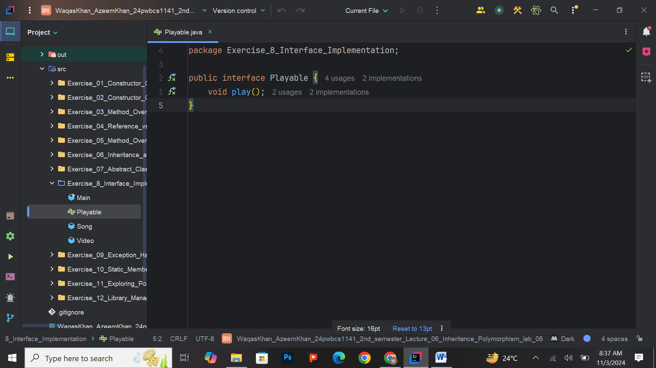

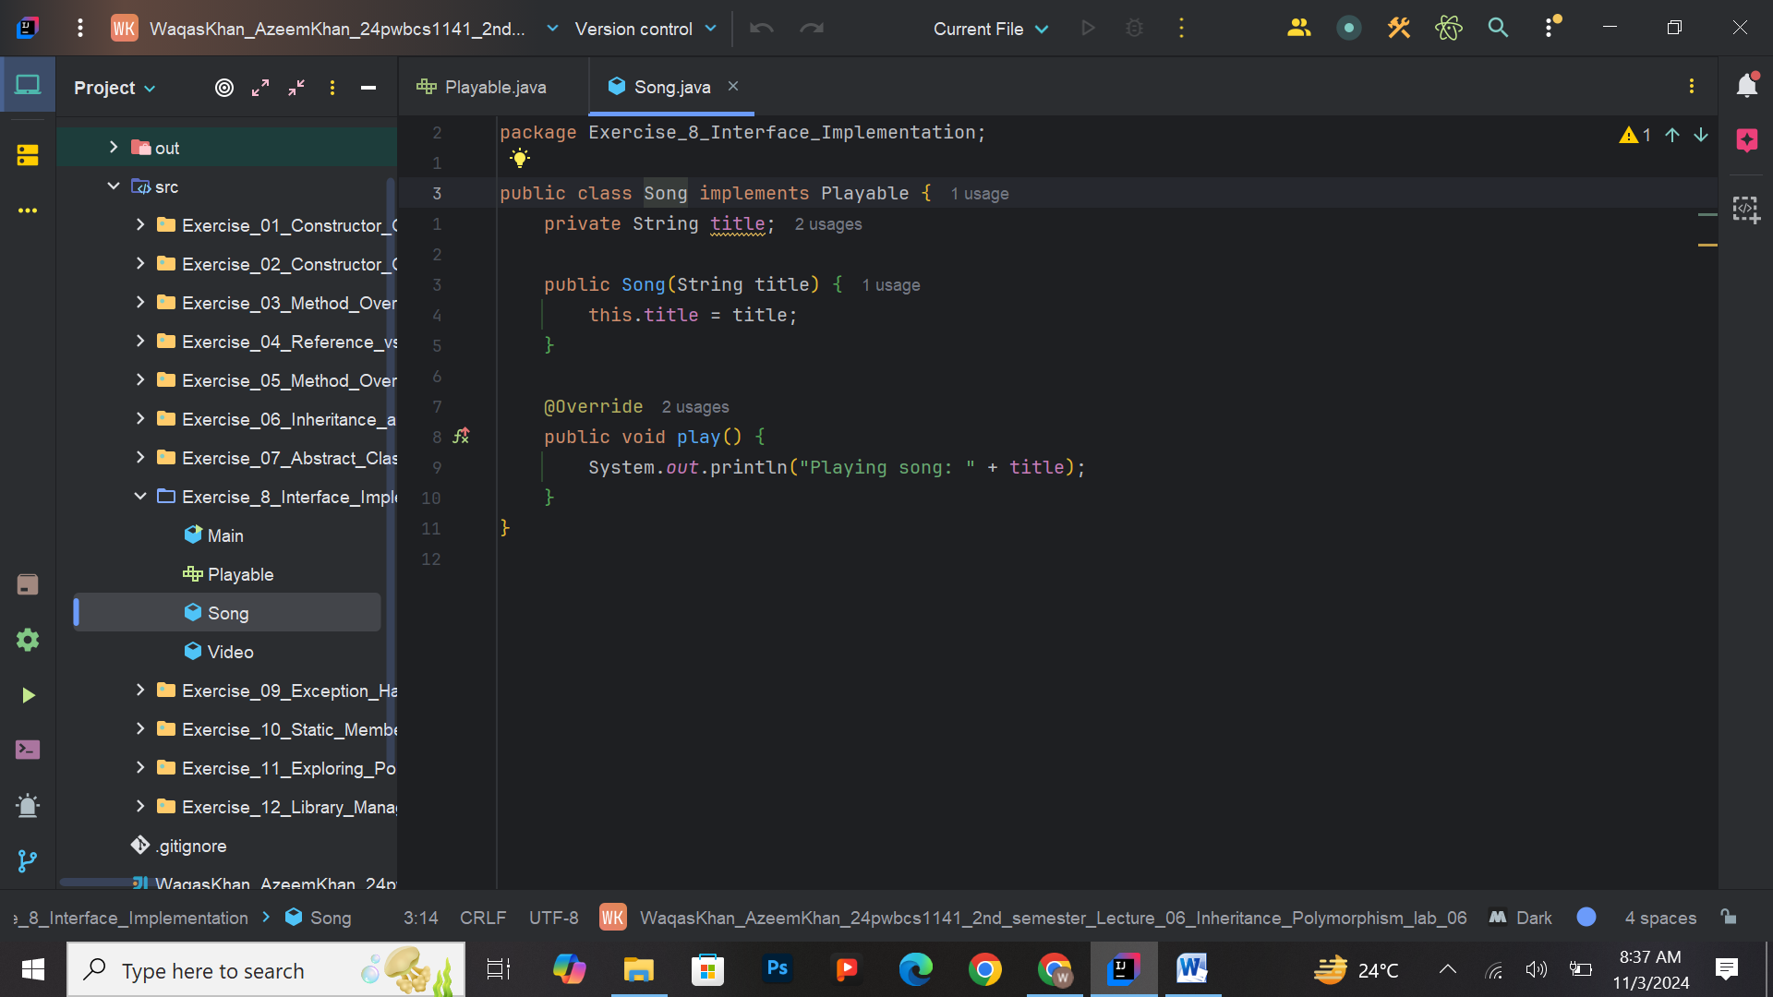

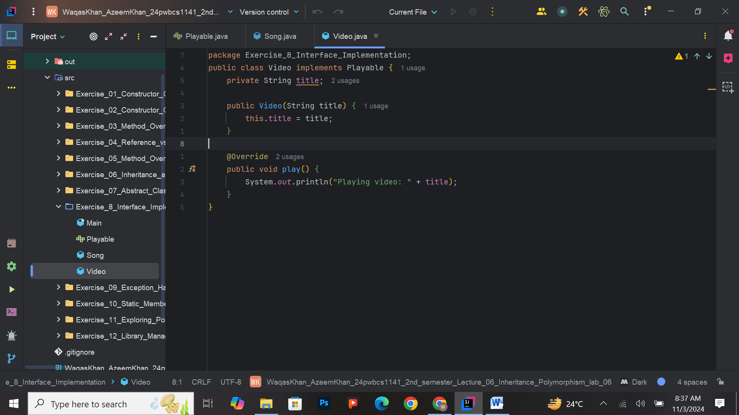

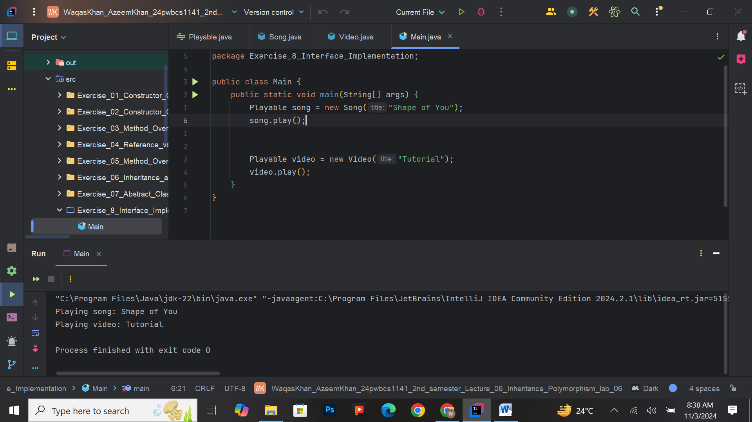

**Exercise 9: Exception Handling**

* **Task:** Create a method divide(int a, int b) that throws an ArithmeticException when dividing by zero. Implement a try-catch block to handle this exception and display an appropriate message.
* **Output:**

Cannot divide by zero.

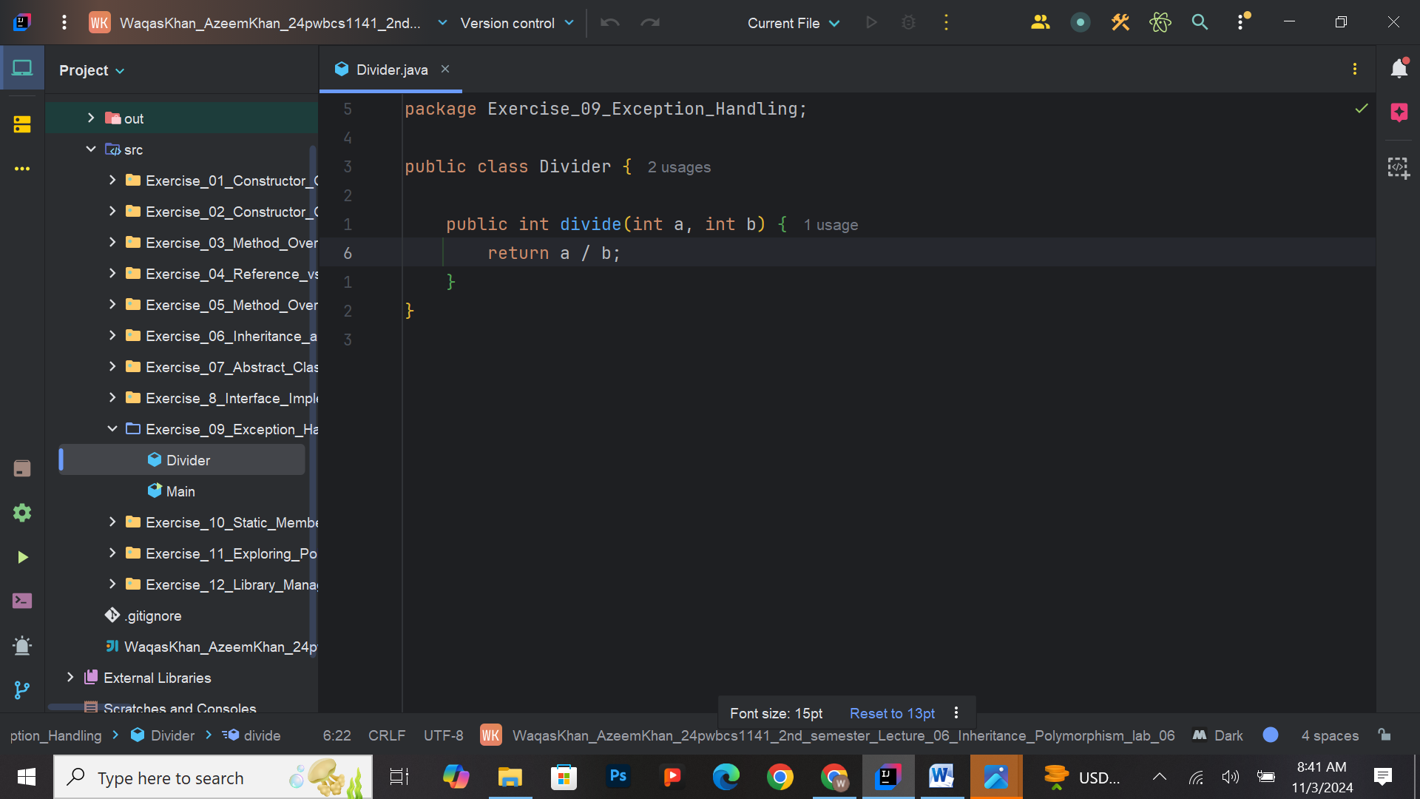

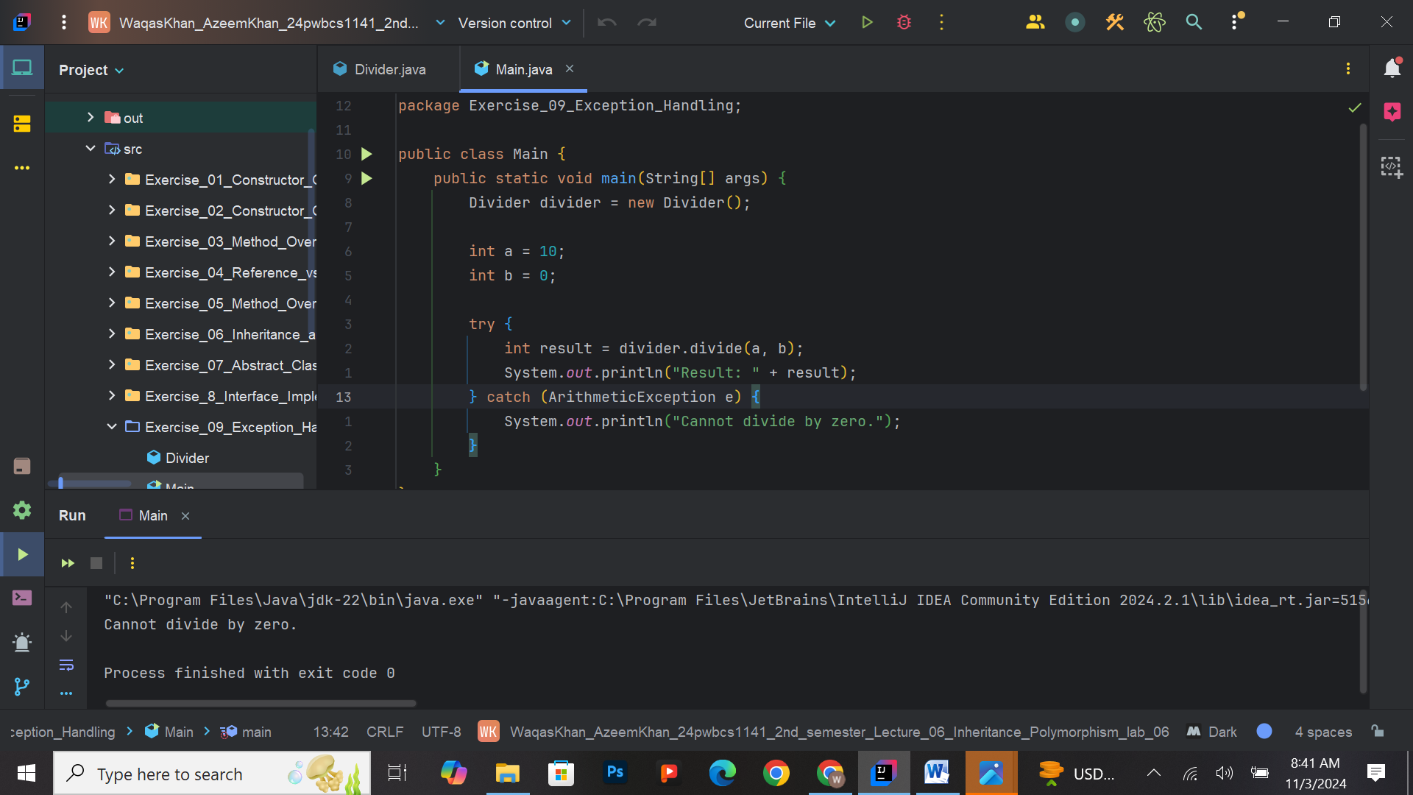

**Exercise 10: Static Members**

* **Task:** Implement a class Counter with a static variable count that increments every time an object is created. Create multiple Counter objects and display the total count.
* **Output:**

Total Count of Objects: 5

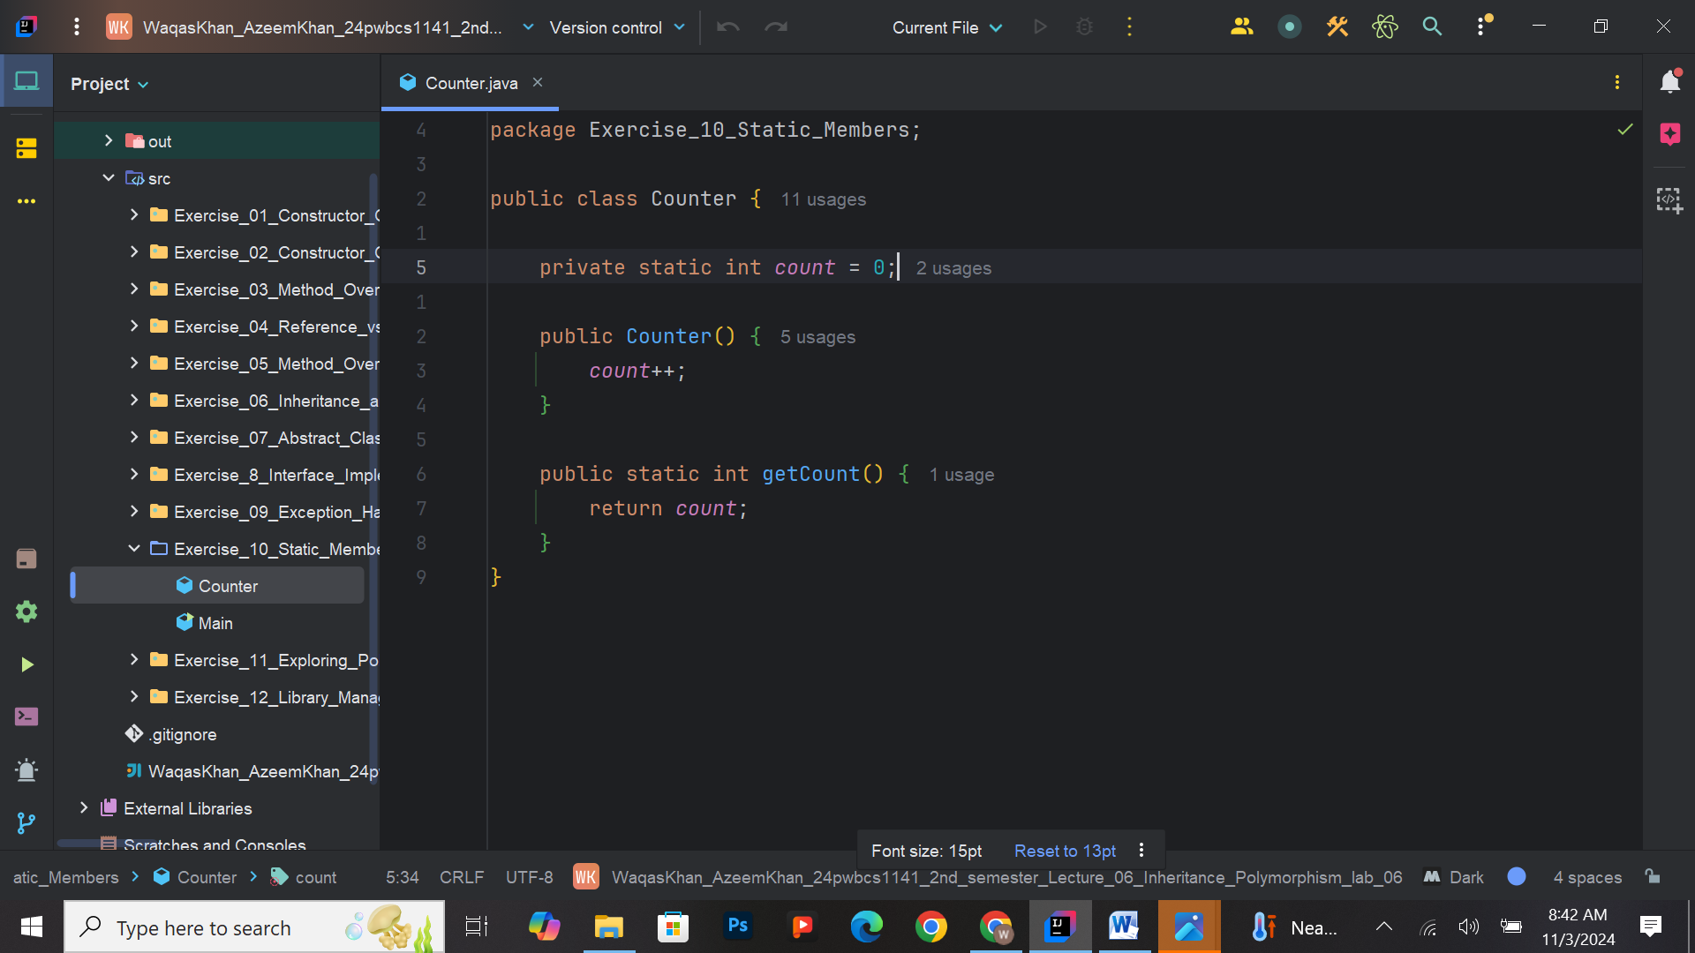

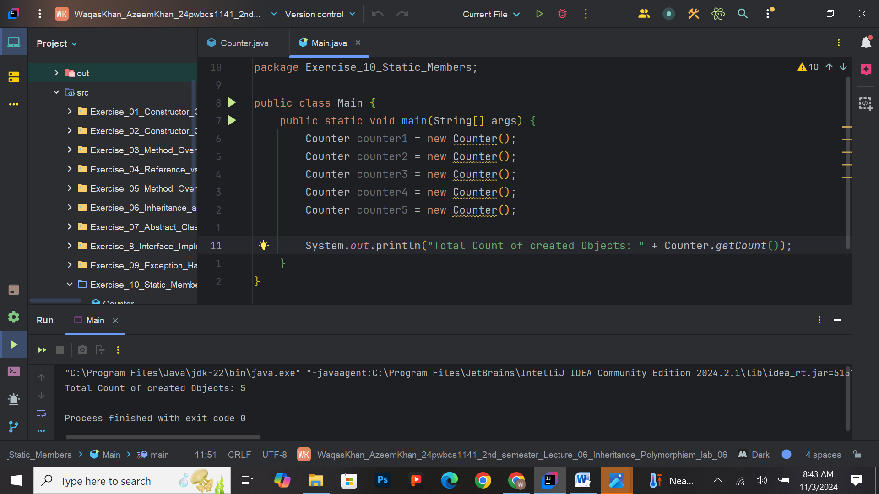

**Exercise 11: Exploring Polymorphism with Method Overriding**

**Task:** Create a base class named Shape with a method draw(). Then, create two subclasses, Circle and Square, each overriding the draw() method to display a specific message for the shape. Demonstrate polymorphism by creating a Shape reference that can point to objects of both Circle and Square.

**Expected Output:**

When calling the draw() method on the Shape reference, it should output the specific messages for both shapes.

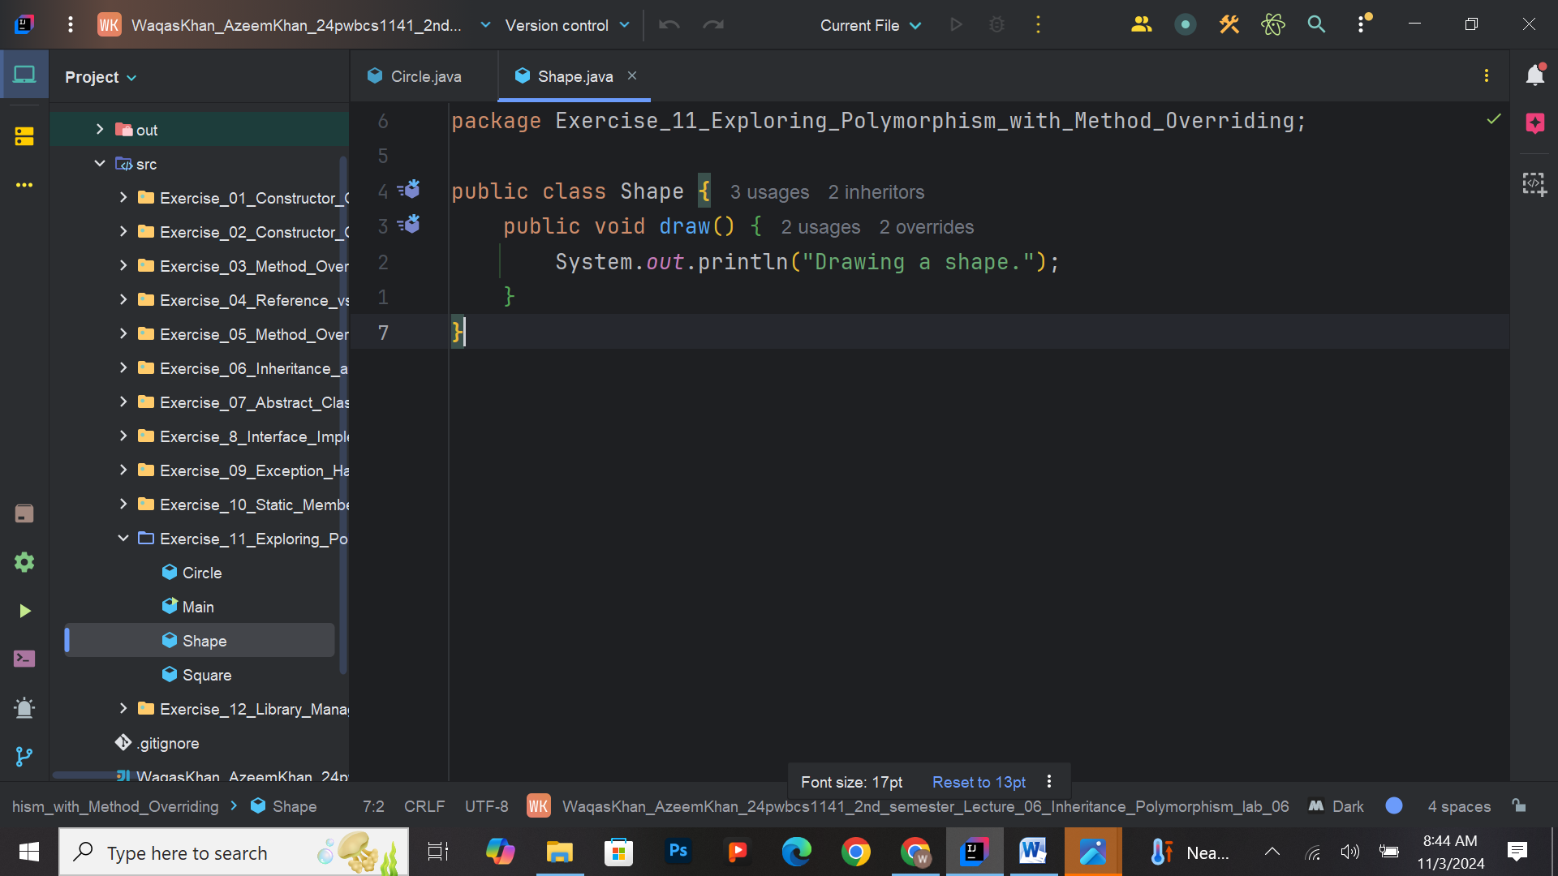

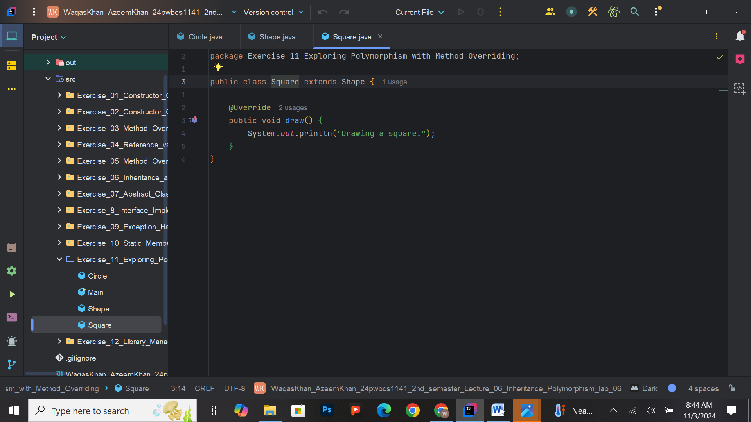

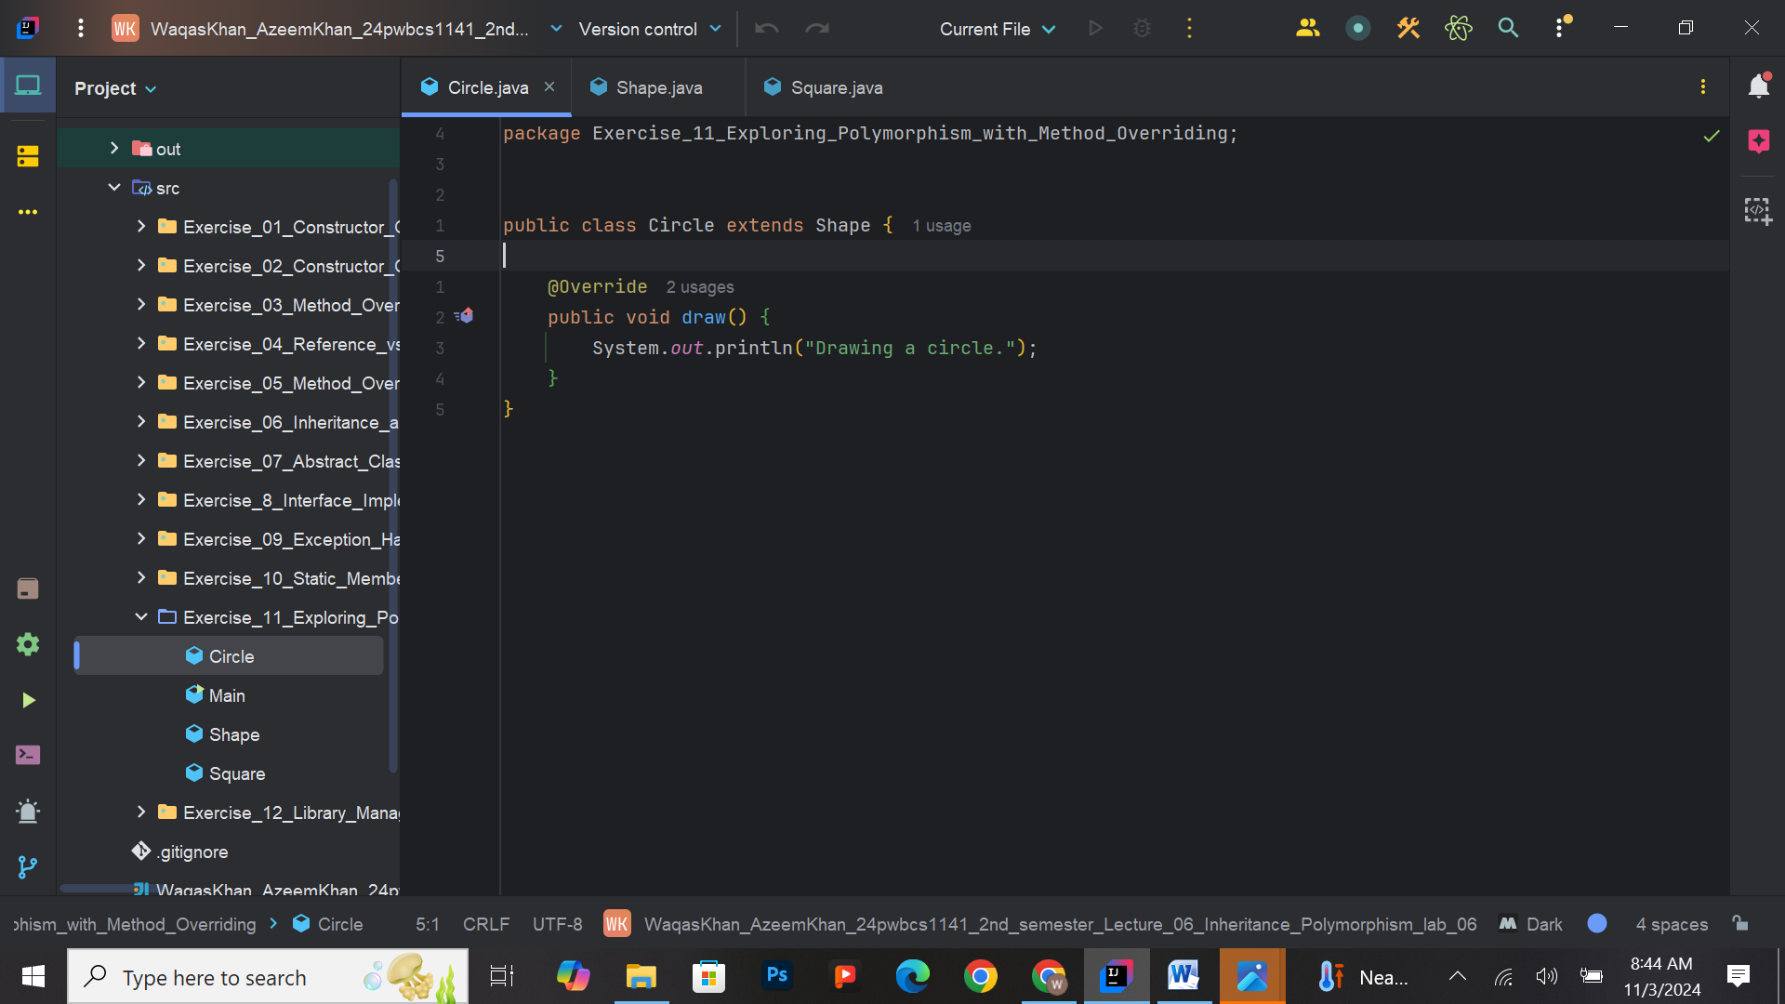

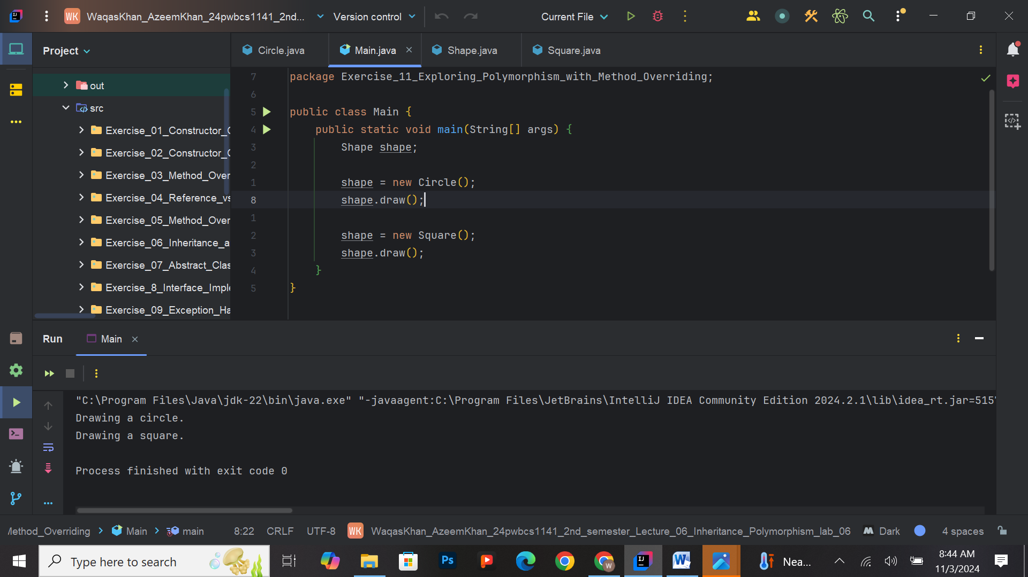

**Exercise 12: Library Management System**

**Task**: Create a simple Library Management System that allows users to add books, view the list of available books, and check out books. Use classes to represent Books and the Library.

